ABIOTIC FACTORS 1  long, cold winters; short, mild summers; moderate precipitation; high humidity; acidic, nutrient-poor soils | ABIOTIC FACTORS 2  low precipitation, variable temperatures; soils rich in minerals but poor in organic material | ABIOTIC FACTORS 3  cold to moderate winters;  warm summers; year-round precipitation; fertile soils
ABIOTIC FACTORS 4  hot and wet year-round;  thin, nutrient-poor soils | ABIOTIC FACTORS 5  warm to hot summers; cold winters; moderate, seasonal precipitation; fertile soils; occasional fires | ABIOTIC FACTORS 6  mild temperatures; abundant precipitation during fall, winter, and spring; relatively cool, dry summer; rocky, acidic soils
ABIOTIC FACTORS 7  warm temperatures in winter; season rainfall; hot dry summers; semiarid, periodic fires, nutrient poor soil | ABIOTIC FACTORS 8  No exposed soil, ice, very little precipiation | ABIOTIC FACTORS 9  strong winds; low precipitation; short and soggy summers; long, cold, and dark winters; poorly developed soils; permafrost
ABIOTIC FACTORS 10
World’s most fertile soils, periodic fires, warm to hot summers, cold winters and seasonal precipitation

DOMINANT PLANTS 1  broad-leaved evergreen trees;  ferns; large woody vines  and climbing plants; orchids  and bromeliads, epiphytes, high diversity |  | DOMINANT PLANTS 2  woody evergreen shrubs with  small, leathery leaves; fragrant,  oily herbs that grow during  winter and die in summer, hot spot for diversity |  | DOMINANT PLANTS 3  Coniferous, leaves have thick waxy coatings and are small, lichens
DOMINANT PLANTS 4  cacti and other succulents;  creosote bush and other  plants with short growth cycles, plants with reduced leaves |  | DOMINANT PLANTS 5  Some algae |  | DOMINANT PLANTS 6  broadleaf deciduous  trees; some conifers;  flowering shrubs; herbs
DOMINANT PLANTS 7  lush, perennial grasses and  herbs |  | DOMINANT PLANTS 8  Redwoods, conifers,epiphytes |  | DOMINANT PLANTS 9  ground-hugging plants such  as mosses, lichens, sedges,  and short grasses
DOMINANT PLANTS 10
Tall grasses, some trees, plants grow leaves during wet season, some turn brown during dry season, fire resistant
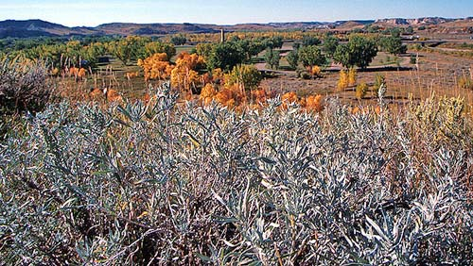  Reno, Nevada | 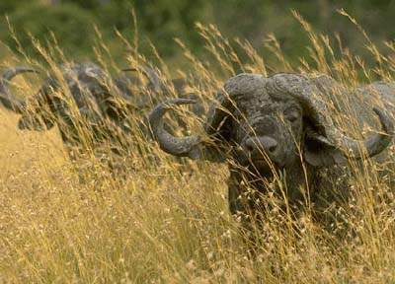  Harare, Zimbabwe |  | 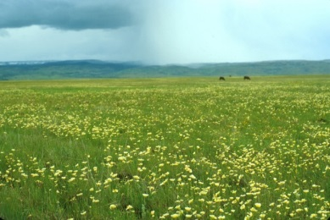  Lawrence, Kansas
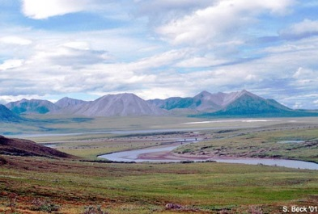  Fort Yukon, Alaska | 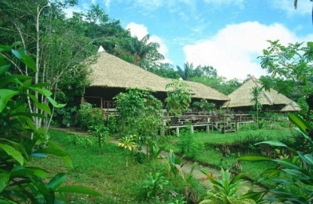  Manaus, Brazil |  | 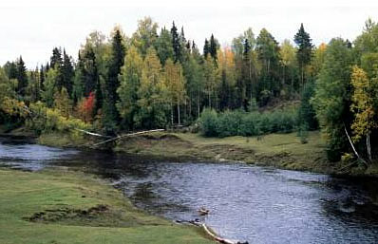  Moscow, Russia
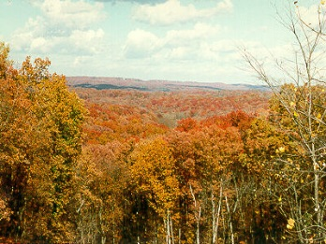  Montpelier, Vermont | 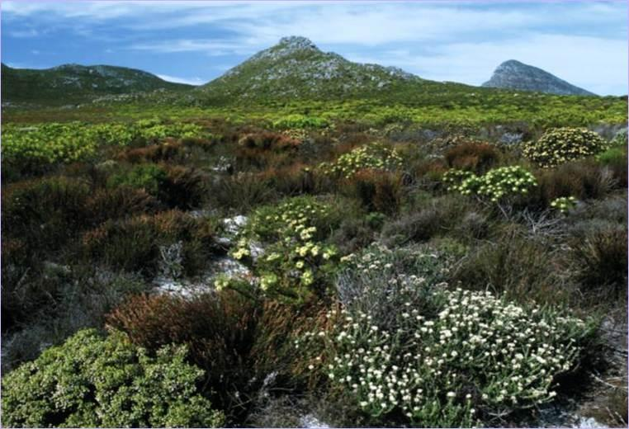  Lisbon, Portugal |  | 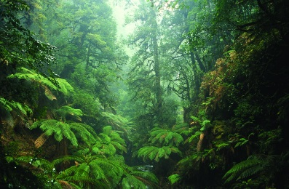  Eugene, Oregon
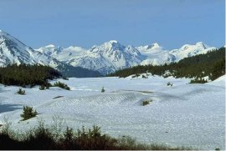  Yakutsk, Russia | 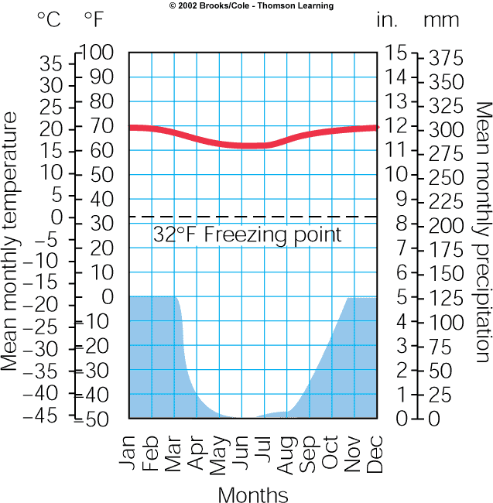  1 |  | 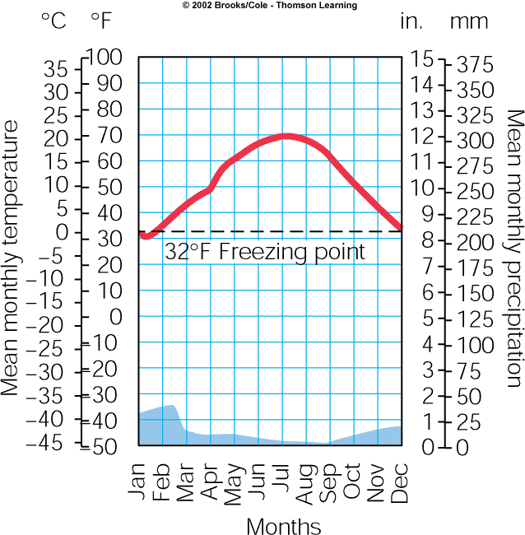  2
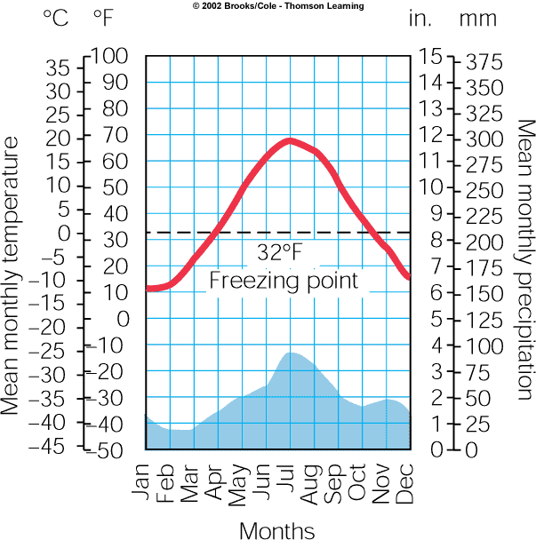  3 | 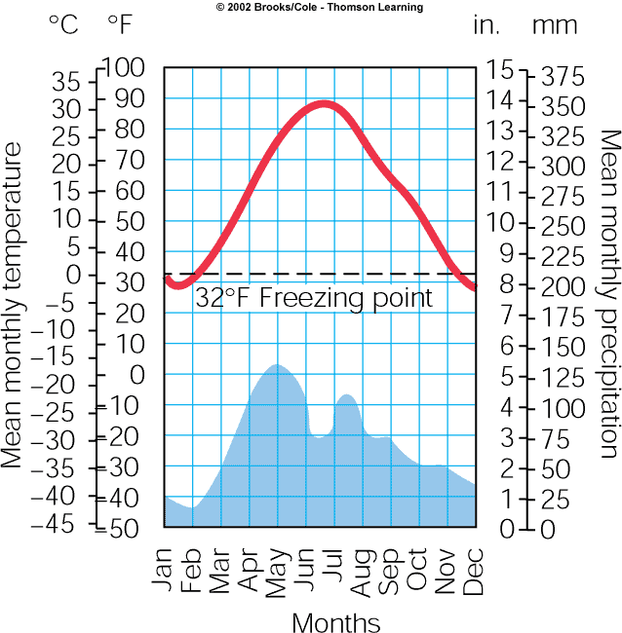  4 |  | 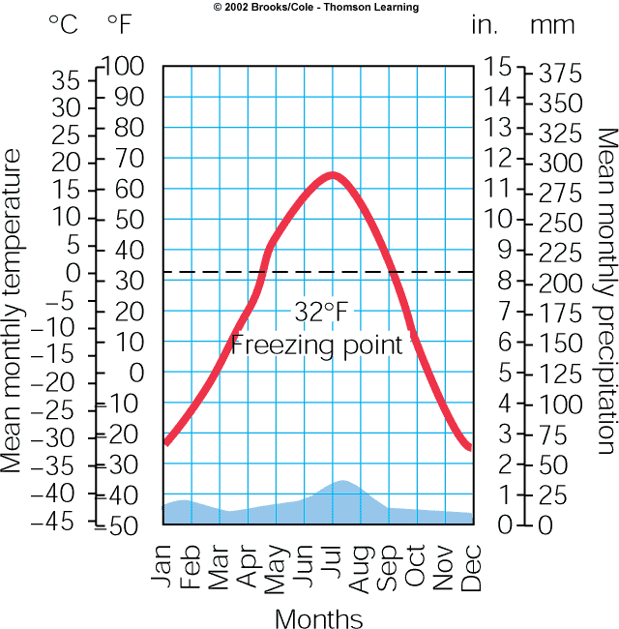  5
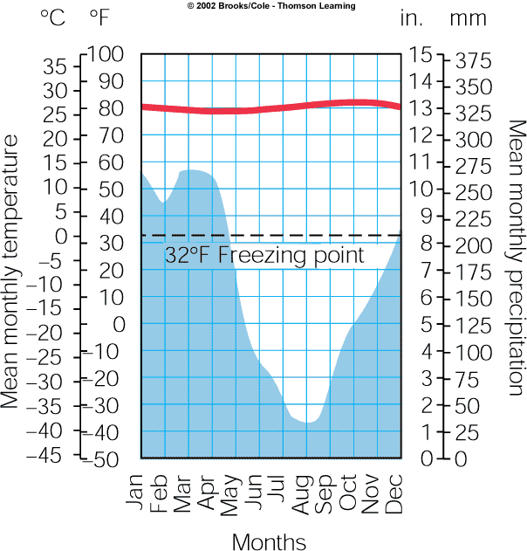  6 | 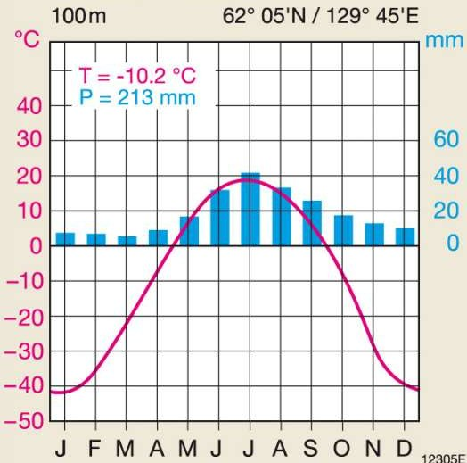  7 |  | 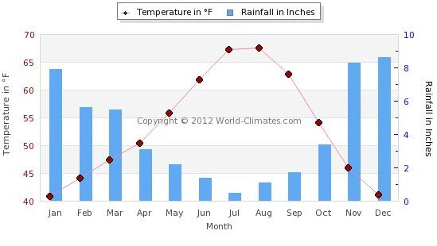  8
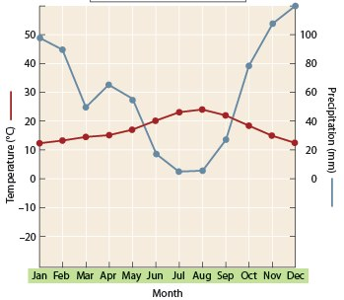  9 | 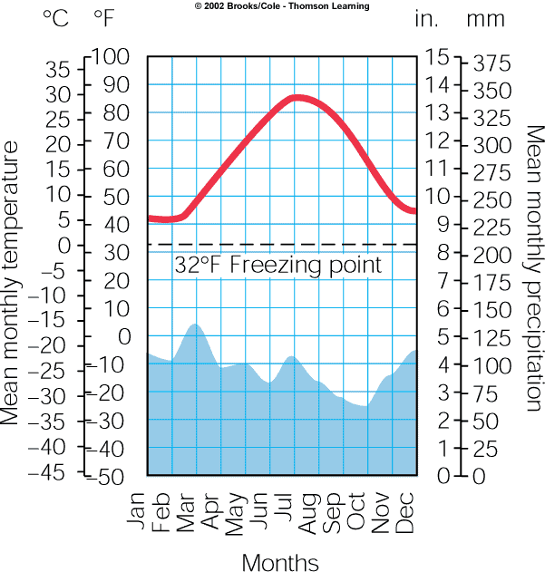  10 |  | #9 is a little confusing  b/c of the precipitation y-axis 0 being up high

ANIMAL 1  Rhino, elephants, zebras  Adaptation:  Migrate due to drought season | ANIMAL 2  Sloth, monkeys, many different kinds  Adaptation:  Specialists | ANIMAL 3  Grouse, mountain lion, moose  Adaptation:
ANIMAL 4  Owls, raccoons, deer  Adaptation:  Birds migrate due to cold winters, some animals may hibernate or torpor | ANIMAL 5  Moose, wolf, lynx, bobcat  Adaptation:  Birds migrate, animals hibernate and have thick fur coats for extreme cold, eat lots of different things | ANIMAL 6  Prairie dog, ferret, bison  Adaptation:  Burrowing, sharp claws to fight predators
ANIMAL 7  Lizards, camels  Adaptation:  Burrowing, nocturnal, store water | ANIMAL 8  gecko  Adaptation:  Small and nocturnal | ANIMAL 9  Reindeer, bear, small rodents  Adaptation:  migrate
ANIMAL 10
None
Adaptation:

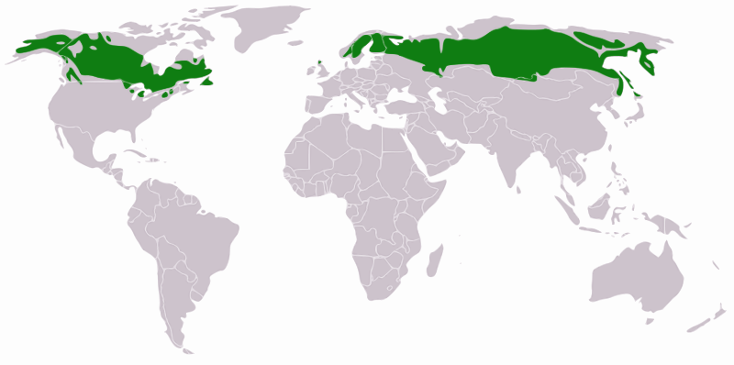  1 | 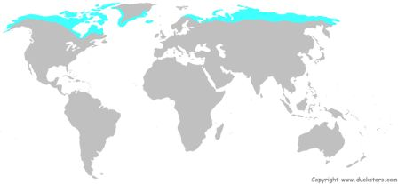  2 | 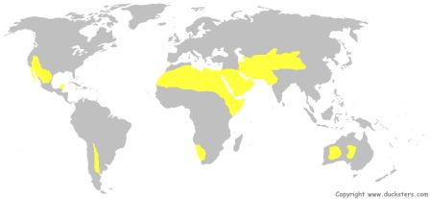  3
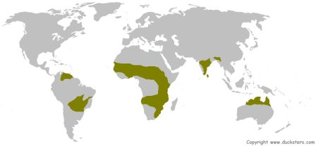  4 | 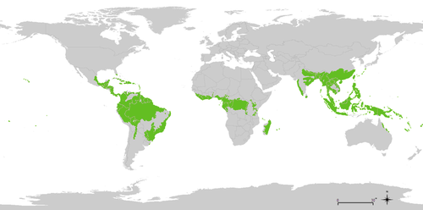  5 | 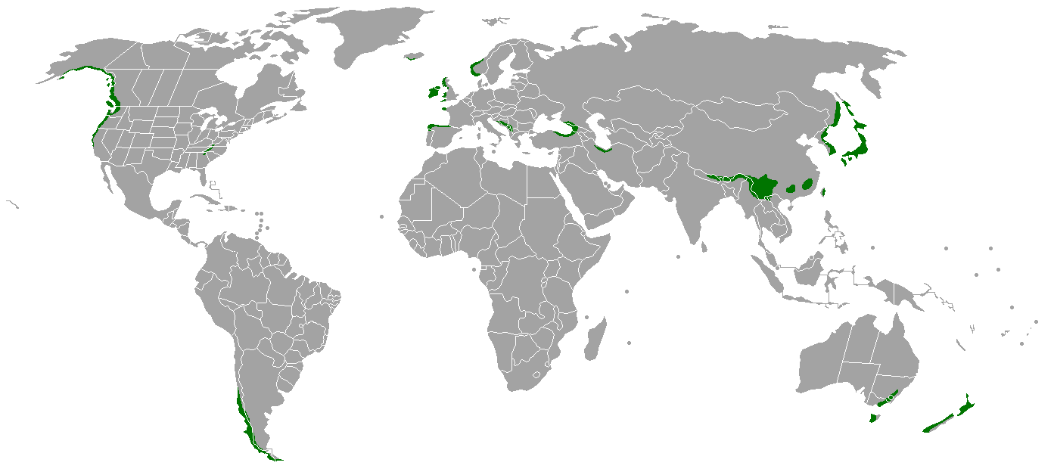  6
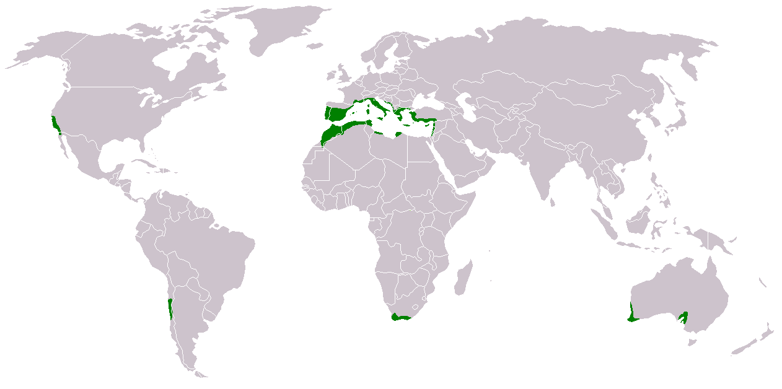  7 | 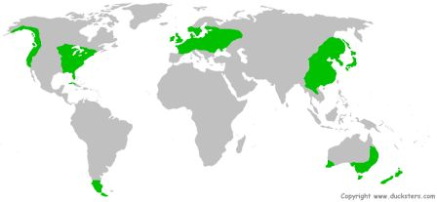  8 | 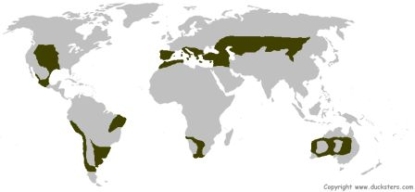  9
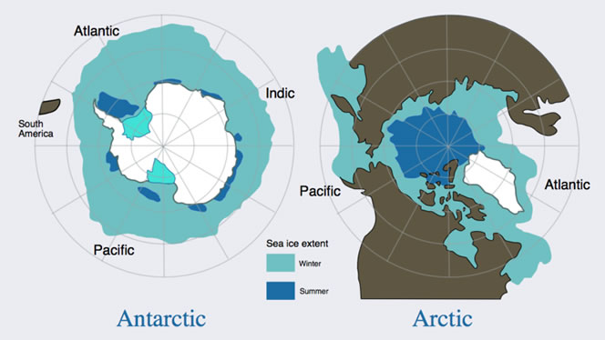  10  Anthropogenic 1  Airborne pollutants, melting of permafrost due to climate change, gas and oil development is a threat | Anthropogenic 2  Development, air pollution | Anthropogenic 3  Airborne pollutants, melting of ice due to climate change
Anthropogenic 4  Desertification, mining, firewood gathering, climate change, overgrazing, fragile ecosystems with fragile soils hurt by recreation vehicles | Anthropogenic 5  Clearing of land, grazing, slash burning, gathering of firewood |  | Anthropogenic 6  Lost habitats due to farming, overgrazing, prevention of periodic fires
Anthropogenic 7  Clearing of forests for farming, soil is unusable after a few years, logging, Wars-Congo | Anthropogenic 8  Exploration of oil, climate change is causing loss of cold adapted species, logging |  | Anthropogenic 9  logging
Anthropogenic 10
Most lost biome, development, ag, acid rain, logging, climate change is changing the amount of precipitation

TROPICAL RAINFOREST | CHAPARRAL |  | POLAR GRASSLAND  (TUNDRA)
ARCTIC/ANTARCTIC POLAR | DESERT  (NO SPECIFIC TEMPERATURE) |  | TEMPERATE DECIDUOUS FOREST
TEMPERATE RAINFOREST | TROPICAL GRASSLAND  (SAVANNA) |  | TEMPERATE GRASSLAND  (PRAIRIE)
TAIGA/BOREAL FOREST

