Last minute hodgepodge review packet
Name that Nitrogen!!
NO- Nitric Oxide
NO₂ – Nitrogen Dioxide
N₂ – Nitrogen Gas
NO₃- Nitrate
N₂O- Nitrous Oxide (GHG)
NH₄ – ammonium
NH₃- ammonia
NOx – Nitrogen Oxides (including NO and NO2)
HNO₃ – Nitric Acid

Consequences of Climate Change:
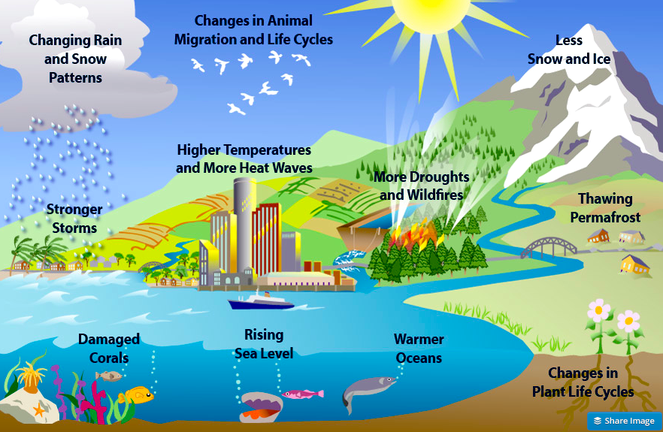

Geologic Time Scale
- Precambrian- longest era
- Paleozoic – when coal deposits were formed
- Mesozoic had dinosaurs
- We live in Cenozoic Era, Quaternary period

Top 8 elements in the earths crust (in order)
* O, Si, Al, Fe (iron), Ca, Na (sodium), P, Mg
Only silly apes in college study past midnight.
Water Testing:
- Acidity measures on the pH scale, pH of 4 has 1x10⁻⁴ hydrogen ion concentrations
  - Distilled water- pH seven
  - Rain water 5.0 to 5.5
  - Acid Rain- 4
  - 1 – acid, 7 neutral, 14 basic/alkaline
- Turbidity- caused by suspended particles (typically from erosion)
  - Increased turbidity can decrease photosynthesis, clog gills of aquatic organisms
- Dissolved Oxygen- measure of oxygen in water
  - Temperature directly decreases D.O.
  - Eutrophication causes a decrease in D.O.
  - Sewage causes decrease in D.O. (similar to eutrophication- decomposition of waste)
  - Major source of D.O. comes from phytoplankton
- Hardness- measures the amount of Ca ⁺² and Mg ⁺²
- Salinity- measures the amount of dissolved salts (sodium chloride) in a given volume of water
- Nitrates/Phosphates
  - From fertilizer (both), detergents (phosphates only)
  - Starts the process of eutrophication
- B.O.D- Biological Oxygen Demand
  - The amount of D.O. needed to break down organic material
  - Low B.O.D is a good thing
  - More organic waste, more oxygen demanding bacteria (similar to eutrophication)
Land Use
Floodplains are important to humans historically because they are fertile, are flat and are close to rivers for transportation

Riperian- the area along side rivers, creeks, streams (the banks)

Artificial levees and embankments will increase the amounts of sediments deposited at the mouth of the river system.
Cleaning air pollution
Scrubbers- In coal burning power plants, once sulfur is burned and produces SO₂, the exhaust gas passes through the scrubber where a spray mixture of limestone and water reacts with the SO₂. The reaction enables the SO₂ to be removed before it's released into the atmosphere.

Catalytic Converters- exhaust emission control device that converts toxic chemicals in the exhaust of an internal combustion engine (cars) into less noxious substances. Converts three main pollutants:
- NO_{x} O₂ + N₂
- CO + O₂ CO₂
- C_{x}H_{2x} (hydrocarbons) + O₂ CO₂ + H₂O
Electrostatic precipitators- a device that removes suspended dust particles from a gas or exhaust by applying a high voltage electrostatic charge and collecting the particles on charged plates
- can remove 99% of particulate matter but does not remove hazardous ultrafine particles.
-Produces toxic dust that must be safely disposed of.
-Uses large amounts of electricity

Places to Know
Chernobyl, Ukraine: April 26, 1986, unauthorized safety test (irony), leads to fire and explosion at nuclear power plant—millions exposed to unsafe levels of radiation.
Three-Mile Island, Pennsylvania: March 29, 1979, nuclear power plant loses cooling water 50% of core melts, radioactive materials escape into atmosphere, near meltdown (disaster).

Fukishima, Japan: March 11, 2011, the Dailchi nuclear power plant that was hit by a tsunami (caused by an earthquake) that produced equioment failures, and without the equipment a loss of coolant accident followed resulting in three nuclear meltdowns and the release of radioactive material (caesium-137 )in to surrounding areas including into the Pacfic Ocean.
Yucca Mountain, Nevada: controversial as proposed site for permanent storage of high-level nuclear waste, 70-miles northwest of Las Vegas, near volcano and earthquake faults.
Aral Sea, Uzbekistan/Kazakhstan (former Soviet Union): large inland sea is drying up as a result of water diversion.
Love Canal, NY: chemicals buried in old canal, school and homes built over it led to birth defects and cancers.
Aswan High Dam, Egypt: the silt that made the Nile region fertile fills the reservoir. Lack of irrigation controls causes waterlogging and salinization. The parasitic disease schistosomiasis thrives in the stagnant water of the reservoir.
Three Gorges Dam, China: world’s largest dam on Yangtze River will drown ecosystems, cities, archeological sites, fragment habitats, and displace 2 million people.
Ogallala Aquifer: world’s largest aquifer; under parts of Wyoming, South Dakota, Nebraska, Kansas, Colorado, Oklahoma, New Mexico, and Texas (the Midwest). Holds enough water to cover the U.S. with 1.5 feet of water. Being depleted for agricultural and urban use.
Minamata, Japan: mental impairments, birth defects, and deaths were caused by mercury dumped in Minamata Bay by factory. Mercury entered humans through their diet (fish).
Bhopal, India: December 2,1984, methyl isocyanate released accidentally by Union Carbide pesticide plant kills over 5,000.

Valdez, Alaska: March 24, 1989, tanker Exxon Valdez hits submerged rocks in Prince William Sound—worst oil spill in US waters until the BP oil spill.

Deep Water Horizon/BP Oil Spill, Gulf of Mexico, April 20, 2010: following the explosion and sinking of the Deepwater Horizon oil rig, a sea-floor oil gusher flowed for 87 days until it was capped on July 15th 2010. Worst accidental marine oil spill.

GPP = NPP + Respiration
NPP = GPP - Respiration

GPP- rate at which producers convert solar energy into chemical energy through photosynthesis
NPP- rate at which producers use photosynthesis and store chemical energy minus the rate they use some energy through respiration (it’s energy left over to pass on to other trophic levels after respiration)

Aquatic Life Zones
Limiting factors in all aquatic life zones
- Light
- Nutrients (oligotrophic, eutrophic)
- Temperature
Fresh Water
- Lentic –non-flowing -- Ponds, Lakes
- Lotic – flowing-- Streams, Rivers, Brooks, Creeks, Swamps, Marshes

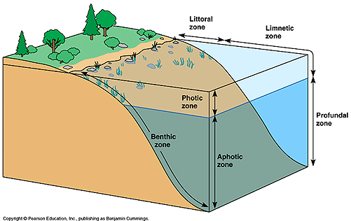
Classification of fresh water organisms.
• Plankton (see under marine systems)
• Nekton –free swimming
• Benthic (epifauna and infauna) on or in the bottom ooze
• Limnetic Zone – euphotic -- depth to where light sufficient for photosynthesis.
• Profundal -- area below the euphotic zone
• Littoral – the shore - rooted aquatic plants like cattails and water lilies
Oligotrophic verses eutrophic lentic systems
Oligotrophic lentic systems have few nutrient and therefore few organisms. They also tend to have deeper water and smaller littoral areas. Eutrophic systems are essentially the opposite of oligotrophic. Most lake/ponds start out oligotrophic and later become eutrophic.

Spring and fall turnovers of nutrients are important to all lentic systems for these bring nutrients up from the bottom into the euphotic zzone.
Wetlands
• Marsh – no trees
• Swamp – has trees
• Prairie potholes
• Flood plains
• Wet arctic tundra

Ecological Services of Fresh Water Systems
• Climate moderation
• Nutrient cycling
• Waste treatment and dilution
• Flood control
• Groundwater recharge
• Habitats for aquatic and terrestrial species
• Genetic resources and biodiversity
• Scientific Information
Economic Services
• Food
• Drinking water
• Irrigation water
• Hydroelectricity
• Transportation corridors
• Recreation
• Employment

Marine—71% of earth’s surface
1. Littoral -- intertidal (Rocky, Sandy Shores)
2. Coral Reefs --- warm waters only. Coral polyps(calcium carbonate) + zooxanthellae
3. Coastal marshes
4. Mangrove swamps
5. Estuaries ---Nurseries of the sea.
6. Ocean
Ocean Life
Classification of marine organisms
• Plankton -- can’t swim against current.
▪ Animals (zooplankton)
▪ Plants ( phytoplankton)
▪ Bacteria
• Nekton
• All animals capable of moving independently of the ocean currents
• Benthos (Benthic)
• Bottom dwellers
• A great number of species exist on the shallow coastal floor
• Most live in perpetual darkness in deep water
• Detritus feeders abundant

Ecological Services
o Climate moderation
o CO₂ absorption
o Nutrient cycling
o Waste treatment and dilution
o Reduced storm impact (mangrove, barrier islands, coastal wetlands)
o Habitats and nursery areas for marine and terrestrial species
o Genetic resources and biodiversity
o Scientific information

Economic Services
o Food
o Animal and pet feed (fish meal)
o Pharmaceuticals
o Harbors and transportation routes
o Coastal habitats for humans
o Recreation
  - Employment
o Offshore oil and natural gas
  - Minerals
  - Building Materials

Marine life zones
• Several factors are used to divide the ocean into distinct marine life zones
1. Availability of light
• Photic (light) zone
• Upper part of ocean, Sunlit
• Euphotic zone is near the surface where the light is strong enough to allow photosynthesis.
• Aphotic (without light) zone
• Deep ocean/ No sunlight
2. Distance from shore
• Intertidal zone –(littoral)—area where land and ocean meet and overlap. Rocky and Sandy shore differences
• Neritic zone – seaward from the low tide line, the continental shelf out to the shelf break
• Oceanic zone – beyond the continental shelf
3. Water depth
o Pelagic zone – open ocean of any depth
o Benthic zone – includes any sea-bottom surface
o Bathyl zone – dimly lit middle zone
o Abyssal zone –
• Deep, dark
• Extremely high water pressure
• Low temperatures
• Sparse life
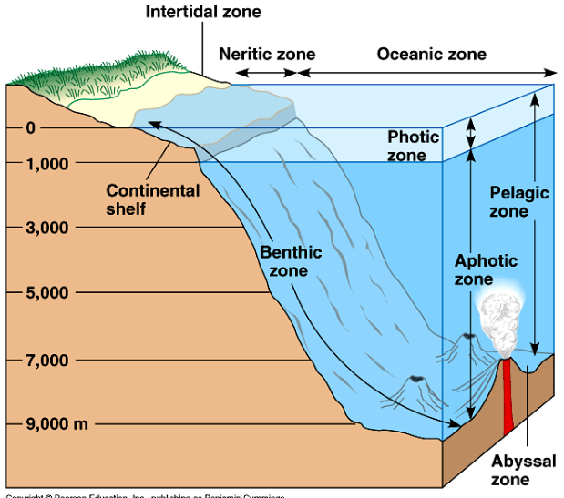
• Food sources include decaying particles from above, large fragments falling, and hydrothermal vents

Greenhouse Gases:
- Multiple Use Public Lands: National Forest & National Resource lands.
- Moderately Restricted Use Public Lands: National Wildlife Refuges
- Restricted Use Public Lands: National Parks & National Wilderness Preservation System
- National Parks- oldest Yellowstone, next Yosemite. these area have multiple roles from providing biological habitat to facilitating human recreation. Roads and buildings can be constructed in these areas.
- National wildlife refuges- preserves lands and waters for the conservation of fishes, wildlife and plants of the United States. Hunting, fishing and photography are permitted on these lands. Roads are built in these refuges
- National Forests-these areas have multiple uses including timber harvest, livestock forage, water resource management, mining, recreation, and habitat for fish and wildlife.
- National wilderness preservation areas- only one of the areas described here where road construction, logging, and mining are banned
  - CO2 (Carbon dioxide)
    - From fossil fuel combustion
    - Deforestation
    - Natural- volcanoes
    - Most abundant greenhouse gas
  - CH4 (methane)
    - Natural sources- wetlands, termites
    - Anthropogenic- animal husbandry, accidental release during transportation of natural gas, rice paddies, landfills, biomass burning
    - Most potent greenhouse gas
  - - Water Vapor
    - No anthropogenic source
    - Most common greenhouse gas
  - N2O- Nitrous Oxide
    - Anthropogenic- fossil fuel combustion from cars, synthetic fertilizers
    - Natural- denitrification
    - ***Contributes to Stratospheric Ozone Depletion in addition to CFCs***
  - CFCs
    - No natural causes
    - From coolants in refrigerators, air conditions, pressurized aerosol cans
    - Contributes to Stratospheric Ozone Depletion
  - Tropospheric Ozone
    - Short lived
    - NOx + VOCs + Sunlight

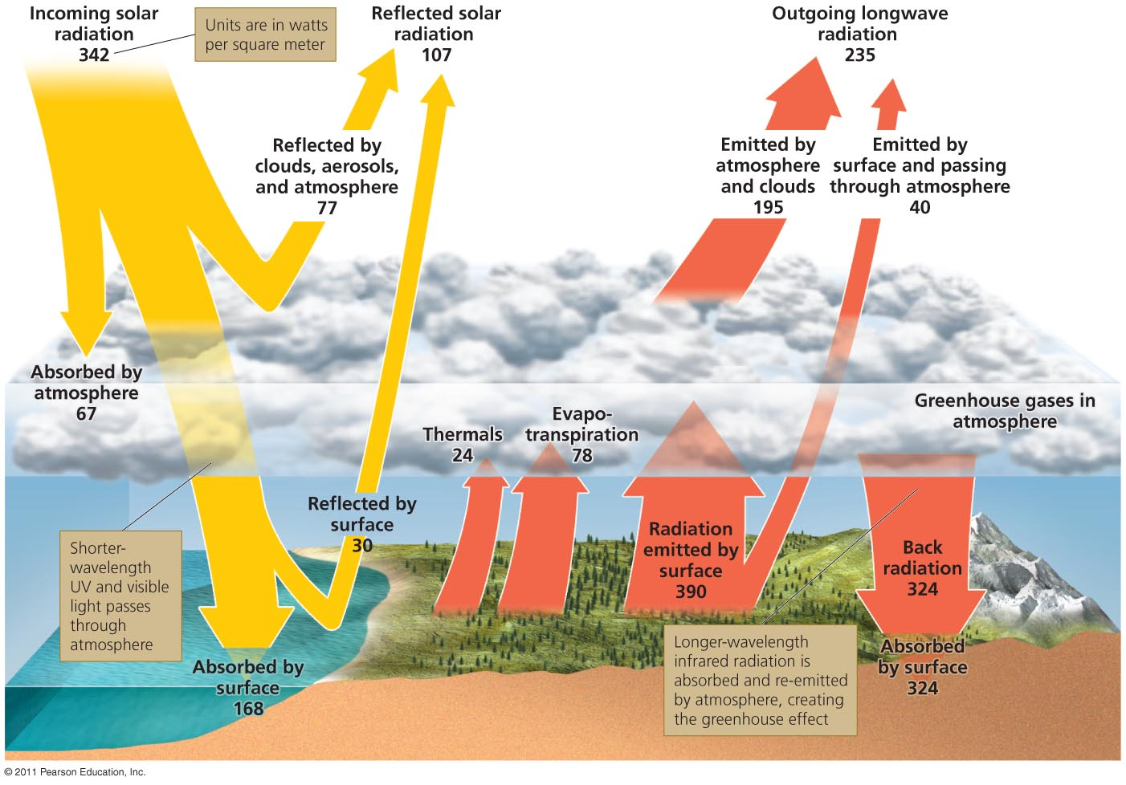
Solid Waste
- Most solid waste comes from agriculture, then manufacturing, then municipal
- The largest component of MSW is PAPER!!!
- 55% of MSW goes to the landfill, 30% is recycled, 15% is incinerated
- The largest contributor to MSW is over packaged products
- The best way to decrease solid waste? SOURCE REDUCTION!!
- Landfills:
  - Lined with clay
  - Collect leachate
  - Produce methane

Hazards/Toxins
Indoor Air Pollutants:
- Asbestos
  - Used as insulation, causes lung cancer, banned in the United States, indoor air pollutant, chemical hazrd
- Radon
  - Colorless, odorless radioactive gas, 2nd leading cause of lung cancer, naturally occurring in bedrock, comes from uranium , chemical hazard
- Formaldehyde
  - Sprayed on particle board, building material, causes headaches and dizziness, chemical hazard
- Tobacco
  - Cultural hazard, leading cause of lung cancer
- Lead
  - Neurotoxin, found in paint chips, leaded gasoline (developed countries), old pipes, heavy metal, children can ingest paint chips or inhale dust with lead paint, chemical hazard
Biological Hazards
- Cholera
  - Biological hazards, caused by bacteria in hazards, causes diarrhea, not found in the U.S. prevent by boiling drinking water
- Malaria
  - Transmitted by mosquitos carrying Plasmodium, prevented by DDT and quinine, not found in the U.S.
- Schistosomiasis
  - Caused by bacteria attacking the lungs found in a parasitic worm but transmitted by water snails, associated with Aswan Dam, avoid by boiling bathing
- Tuberculosis
  - Caused by bacteria that attacks the lungs, spread by breathing/coughing
- West Nile Virus
  - Transmitted by mosquitos, prevent by draining pools of standing water, wear insect repellent

Cultural Hazards
- Tobacco (see indoor air pollutants)
- Obesity
  - Over nourishment, developed countries, causes cardiovascular disease and diabetes
- HIV/AIDS
  - Sub-saharan Africa, attacks immune systems, exchange of bodily fluids

Other
- Atrazine
  - Persistent pesticide, endocrine disruptor (causes deformities in frogs), chemical hazard
- Bisphenol- A (BPA)
  - Found in soft plastics (once in baby bottles and toys), lining of tin cans, cosmetics, fragrances, endocrine disruptor, chemical hazard
- Cadmium-
  - Toxic heavy metal, released when coal is burned, found in incinerator ash, found in batteries that can leach in landfills, neurotoxin
- DDT
  - Endocrine disruptor, banned in the U.S. but still persists, high concentrations in predatory birds, example of biomagnification, persistent pesticide
- Mercury
  - Neurotixon, enters food chain through fish, example of biomagnification, toxic heavy metal, released from coal combustion, mine tailings, found in fish/shellfish at high trophic levels
- Minamata Disease
  - Chemical hazard, caused by mercury poisoning, “Dancing Cats of Japan” (happened in Minamata Japan), causes tumors in adults, birth defects in children, neurotoxin, example of biomagnification
- PBDE
  - Chemical hazard, found in fire retardants and electronics, endocrine disruptor, bioaccumulation in tissue
- PCB
  - Industrial chemical, banned in the US but still persists, found in Arctic animals like polar bears
- Phthalates
  - Chemical hazards, endocrine disruptor, banned in Europe, found is cosmetics, causes birth defects, breast cancer, low sperm count in men

El Nino-Southern Oschillation (ENSO)
El Niño is a disruption of the ocean-atmosphere system in the tropical Pacific with important consequences for weather around the globe. In "normal", non-El Niño conditions, the trade winds blow toward the west across the tropical Pacific. These winds pile up surface water in the western Pacific, so that the sea surface is about 0.5 meter higher at Indonesia than at Ecuador. The sea surface temperature is about 8 degrees C higher in the western Pacific, and cool temperatures prevail off South America (eastern Pacific), due to an upwelling of cold water from deeper levels. This cold water is nutrient-rich, supporting high levels of primary productivity, diverse marine ecosystems, and major fisheries. Rainfall is found in rising air over the warmest water in the western Pacific, and the eastern Pacific is relatively dry.
During El Niño, the trade winds which normally blow west towards Indonesia, relax in the central and western Pacific, allowing normally cool, nutrient-rich waters off of South America to warm significantly, leading to a decline in these fisheries. As the Pacific's warmest water spreads eastward, the hot humid air which fuels thunderstorms moves with it. El Niño changes the position of the jet stream, winds which affect the weather not only in North and South America, but as far away as Africa and Antarctica.
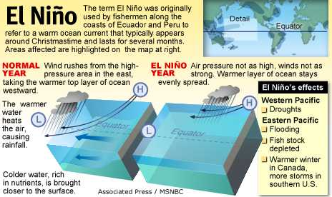
Among the consequences of El Niños are increased rainfall across the southern tier of the U.S. and Peru that has caused destructive flooding, and drought in the western Pacific that is sometimes associated with devastating brush fires in Australia. Observations of conditions in the tropical Pacific are considered essential for the prediction of short term (a few months to 1 year) climate variations.

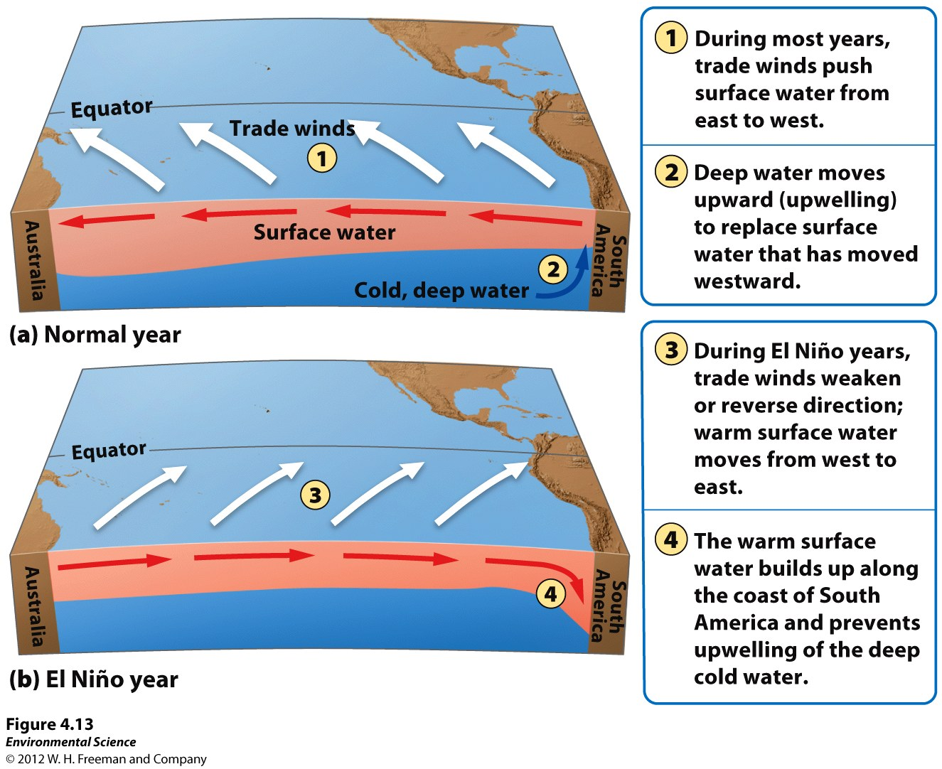

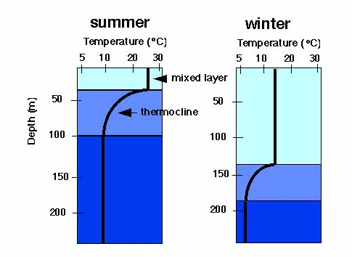
People to know
- Garrett Hardin- coined the term Tragedy of the Commons
- Rachel Carson- wrote Silent Spring- exposed the environmental issues of DDT on predatory birds
- Paul Ehrlich - created the IPAT equation, wrote The Population Bomb
- Thomas Malthus- hypothesized human population would grow exponentially while food production would grow linearly leading to famine, war, etc. He did not anticipate technological advances
- John Muir- established Yosemite National Park
A thermocline (sometimes metalimnion in lakes) is a thin but distinct layer in a large body of fluid (e.g. water, such as an ocean or lake, or air, such as an atmosphere) in which temperature changes more rapidly with depth than it does in the layers above or below.

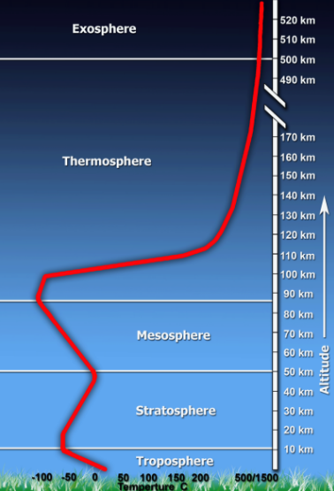

Layers of the Atmosphere

