|  |  |
| --- | --- |
| **Introduction**  Ballistics is the study of what happens to moving projectiles in the barrel and in flight; their trajectory, force, impact, and penetration. The trajectory, or the path a bullet travels from muzzle to impact, of a projectile can be determined if two reference points for the projectile can be found. | |
| Use the following link to access the PHET projectiles in motion lab:  <https://phet.colorado.edu/en/simulation/projectile-motion> If this one does not seem to work, you can try the older flash version: <https://phet.colorado.edu/en/simulation/legacy/projectile-motion> | |
| **Part 1** | |
| Without changing any settings, select 3 different objects in the pull down menu and fire ***without*** air resistance. Which objects did you select AND what do you notice about the path of the objects you selected? |  |
| Now select the air resistance button and fire the same three objects. What did you notice about the flight paths with resistance? |  |
| What does air resistance do to a projectile? Why? |  |
| **Part 2** | |
| Move the target to a distance 20 meters from the cannon. With air resistance off and using the golf ball try each of the following shots. | |  |  |  |  |  |  | | --- | --- | --- | --- | --- | --- | | Angle  (degrees) | 75° | 45° | 15° | 89.4° | 9.3° | | Initial Speed (m/sec) | 20 m/sec | 14 m/sec | 20 m/sec | 98 m/sec | 24.8 m/sec | | Hit or Miss |  |  |  |  |  | |
| What did you notice about angles 75◦ and 15◦? |  |
| **Part 3** | |
| Using the magnifying glass move the target to 490 meters. Fire the golf ball with no air resistance with Angle 45° and Initial Speed 69.3 m/sec. This is Trajectory A.  Without erasing fire again with Angle 75° and Initial Speed of 50.7 m/sec. This is Trajectory B.  Use the tape measure; measure the height of each vertex and the length of each trajectory. | |  |  |  | | --- | --- | --- | |  | Trajectory A | Trajectory B | | Height of Vertex (m) |  |  | | Length of Trajectory (m) |  |  | | Duration—seconds in air |  |  | |
| Calculate the horizontal speed of each trajectory. Horizontal speed (m/sec) | |  |  | | --- | --- | | Trajectory A | Trajectory B | |  |  | |
| **Part 4** | |
| Explain how an understanding of projectiles in motion help investigators determine the location of a sniper in a case such as the JFK assassination? |  |
| **Part 5** | |

Solve the following problems and SHOW ALL WORK to receive credit.

**Scenario 1:**

A victim was shot from a bullet that came through his front car window as shown in the figure below. Witnesses saw a muzzle flash from a nearby building, but were unsure from which floor the flash originated. The path or trajectory can be determined by using Point 1 (P1), the broken driver’s side window and Point 2 (P2), the point where the bullet entered the victim’s head. These points provide two reference points used to determine the angle of the shooter’s position above the driver’s location.

1. According to the sketch, the angle of trajectory is 2 degrees.
2. The distance to the building in question is 40 feet.
3. 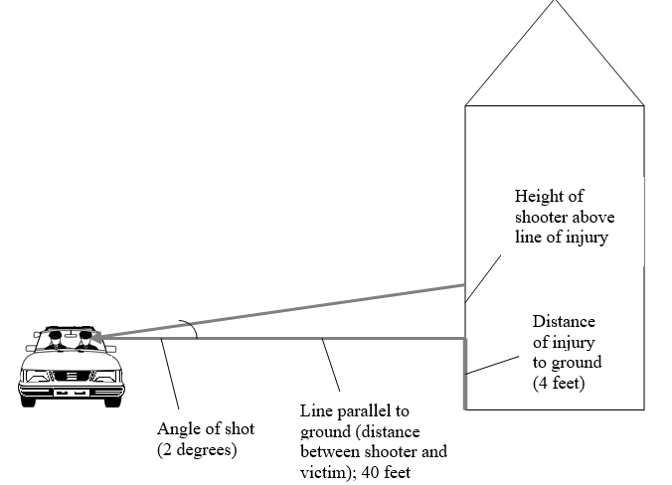Calculate the height of the shooter using tan (angle) = height / distance. (Remember the total height of the shooter is equal to your calculated height plus the height from the injury to the ground.)

**Scenario 2:**

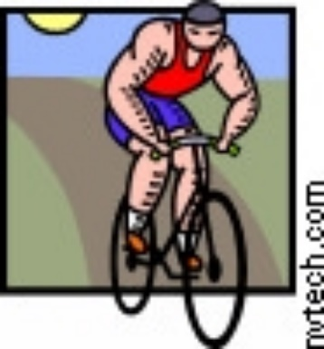Witnesses saw a victim fall while riding his bike. He had been struck in the head by a bullet. When the crime scene investigators arrived, they calculated the angle of elevation of the shooter to be about 6.5 degrees. The distance to the building from which the shot was fired was 152 feet and the height of the entry wound on the victim while on his bike measured 6 feet above the ground. Solve for the height of the shooter (above the ground, not above the victim’s injury).

**Scenario 3:**

A man is shot from a hotel window while sitting on a park bench. Use the following information to determine from which window the shot came. The trajectory angle is 25 degrees. The distance to the hotel is 100 feet and the person’s injury was five feet off the ground.



1. Label the diagram as shown in scenario 1 with all required information.
2. Calculate the distance above the ground where the shot was fired.
3. Which floor do you think the shooter was most likely standing in when he/she shot? Assume the average distance between floors in a hotel is 9 ½ feet.

**Final Analysis:**

1. List 3 possible problems that might interfere with the accuracy of your results or an investigator’s results.

Solve the following:

2. Angle of entry (trajectory) = 15° and the distance to the building is 700 feet Height of shooter ~__________ feet (above the horizon since the person could be sitting or standing and not be at ground level)

3. Angle of entry (trajectory) = 27° and the distance to the building is 60 feet Height of shooter ~__________ feet above the horizon

4. Angle of entry (trajectory) = 35° and the distance to the building is 85 feet Height of shooter ~__________ feet above the horizon

**Ballistics Lab**   
Read the tutorial once logged in.  Do Cartridges 1st (Much easier!)    
Go to [www.firearmsid.com/classroom/class_login.htm​](http://www.firearmsid.com/classroom/class_login.htm)   
​**Use both your first and last name to login so you can get credit** then choose the login key for your class.  Be careful not to use the incorrect code!  
login key for website  =  **2nd period c743812     3rd period c743813**     **4th period c743814**      
​You will be doing the Virtual Comparison Microscope labs.  **READ** the instructions completely before trying or you will be confused!  
For cartridges: You need a 75% or higher on **2** of the tests.    
For bullets: You need a 25% or higher on **1** of the tests.

**Ballistics Hands-On Lab**

1. Caliber - Get a container with bullets and a caliper from up front. Measure the diameter of the bullets in both millimeters and inches and determine the caliber of each. The answers are in the container. How did you do? Explain.
2. Look at the bullets in the jar and see which ones came from the same gun.

What did you observe?

Look at the cartridges in another jar and see which came from the same gun.

What did you observe?

1. Get the container with fingerprinting supplies. Make a fingerprint on a cartridge and see if you can lift it. Tape it on here:
2. Get the container with miscellaneous items related to bullets. Look through them. What is one thing new you have learned from looking at them?

**Tool Marks Hands-On Lab**

Use various tools to make marks in Styrofoam. Imagine you are working a crime scene where a door was pried open. Would it be possible to determine the tool used? Explain.