Study Guide for Unit 1 Test
- State what relationship between the number of protons, neutrons, and electron in an atom to form:
- a neutral atom (p. 114) -
b. an ion (cations p.207 and anions p. 209) -
c. the mass number (p.117)-

Complete #72 on page 129 here:

- Provide the location of the protons, neutrons and electrons in an atom (p. 114)

- Calculate the number of neutrons, protons and electrons of an atom by looking at an element’s information on the periodic table. Draw and label this information for the element given below:
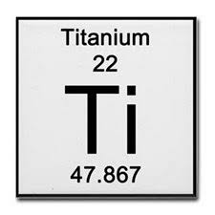
- State the contributions of the following to the modern atomic theory (Chapter 4):
a. Thomson-
b. Rutherford (describe the gold foil experiment)-
c. Bohr-
d. Chadwick-

- The number of orbitals, and total electrons, and shapes for (use your notes):
a. s orbitals-
b. p orbitals-
c. d orbitals (no shape needed)-
d. f orbitals (no shape needed)-

- Describe the following ideas regarding electron configurations:
a. Aufbau Principle p. 156-
b. Hund’s Rule p. 157-
c. Pauli Exclusion Principle p. 157-

- Describe how atomic emission spectrums are created by the movement of electrons (refer to ground and excited state) (Use Electrons and Light POGIL that we colored on)

*Hint: recognize that all atoms of the same element have same spectrum no matter where they are in the universe (stars, earth, comets, etc).

- Atoms in the same _____________ have similar chemical/physical properties because their atoms have the same number of ___________________ electrons. (p. 206)

- Fill in the periodic table below with the number of valence electrons (p. 207- count dots in table 1) AND the charge for an atom once they become ions (p. 208) for groups 1, 2, and 13-18
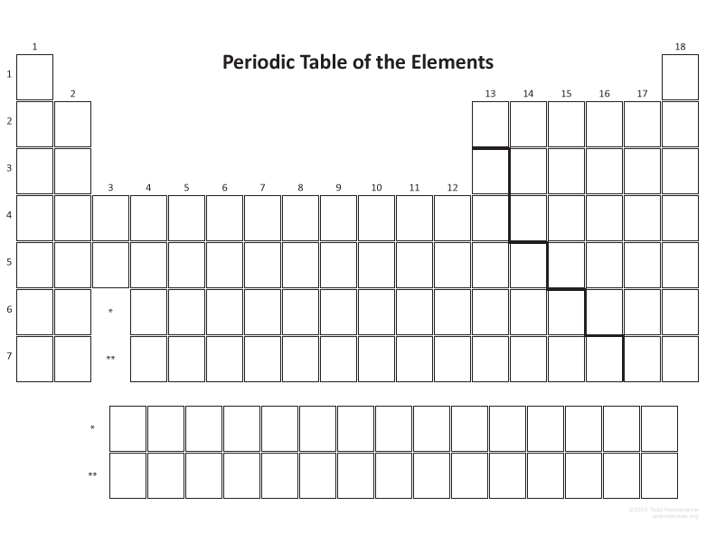
- Fill in the periodic table above with the trends for atomic radius (p. 187-188), ionization energy (191-192) and electronegativity (p. 194)
- Describe what makes two atoms isotopes of each other (p. 117) and explain how to calculate an element’s atomic mass given the relative abundances of its isotopes (p. 121)

Complete #104 on page 130 here:

- On the test, you will be given an atom, or ions for honors, and asked to provide the electron configuration, noble gas configuration, orbital filling diagram, Bohr model and the number of total electrons. Complete the problems below:
#85 a-d on p. 167 *ALSO DO BOHR MODELS!

13. ______________ are positively charged ions and are formed when atoms ________________ electrons. (p. 207). __________________ are negatively charged ions and are formed when atoms _______________ electrons. (p. 209).

