**Unit 4 Stations Activity – Complete in any order. Due end of class on Monday. Late work will receive 10% off per day.**

1. Take notes from the Sand, Soil, Pollen PowerPoint from my website or CTLS. You need general information. The idea is to understand how they can tell sand, soil, pollen came from the area where the body was found or did it come from somewhere else.
2. Complete comparison of trace evidence slides
3. Complete comparison of sand lab
4. Take notes on Glass PowerPoint
5. Complete the Refraction/Bending Light Virtual Lab
6. Complete Virtual Density Lab
7. Glass Shatter Pattern Lab - Must takes notes before doing this so it makes sense.
8. Take notes from the ballistics and firearms notes. Must do this before the hands-on labs so it makes sense.

(I have a video on bisesi.weebly.com you can watch instead)

1. Complete the Projectiles in Motion virtual lab
2. Complete the problems on the Projectiles in motion worksheet. Read carefully. You can do the math! Set up the problem with the knowns and ID what is unknown. Help one another BUT everyone needs to be able to do it themselves.
3. Complete Ballistics Hands-on Labs at the front of the room
4. Complete the Toolmarks Hands-on Lab
5. Work on Serial Killer Project.

**Trace Evidence**

Look through the trace evidence slides using a compound microscope (1 eyepiece). Make sure to look at pollen. Describe 6 of the slides below:

|  |  |  |
| --- | --- | --- |
| Sample: | Sample: | Sample: |
| Sample: | Sample: | Sample: |

**Sand Evidence**

Look through the sand samples using a stereomicroscope (has 2 eyepieces) Describe 6 of the sands below:

|  |  |  |
| --- | --- | --- |
| Sample: | Sample: | Sample: |
| Sample: | Sample: | Sample: |

Which sand sample is your favorite? Why?

|  |  |
| --- | --- |
| **Refraction/Bending of Light**  Refraction is the change in the direction of light as it speeds up or slows down when moving from one medium (substance) to another. Refractive index is another commonly used technique in forensics labs to help match glass and mineral from suspects, victims, and crime scenes. | |
| Use the following link for this part of the assignment.  <https://phet.colorado.edu/sims/html/bending-light/latest/bending-light_en.html> | |
| When the simulator window opens, you should notice a laser pointing at a **45o angle downwards to the right**.Look to the right of the window and notice that the two information boxes are explaining the mediums that are shown on the screen. As you proceed through the lab, you will be guided what to do so you may answer the questions. | |
| Before changing any settings, what **2 mediums** are shown in the simulation window? |  |
| Click on the **RED** button on the laser. What **TWO** things does the light do as it hits the surface of the water? |  |
| On the bottom left side of the simulator window, you should notice that you have two tools available for you to use. Select the bottom tool that looks a bit like a **magnifying glass**. Move the tool into the **general water area**.  Take the **LENS** and drag it directly over the light coming from the laser **BEFORE** it hits the surface of the water. Notice you can measure the intensity of the light when the lens is placed over the beam. Fill in the table. | |  |  | | --- | --- | | **Laser pointed @ 45o angle from vertical** | | | **Location of Lens** | **Intensity of Light** | | Beam of light BEFORE it hits the surface of the water |  | | Beam of light in the water |  | | Beam of light being reflected off of the surface |  | |
| Now, select the protractor from the toolbox and position it so the 0 degree mark is centered on the dashed vertical line. Move the laser pointer so that you ***change*** the angle of incoming light. Adjust the laser point so that it is only **10o to the left of the zero mark or vertical dotted line**. Once the laser pointer is in this location, move the protractor tool back to the tool box and fill in the table again below using the lens. | |  |  | | --- | --- | | **Laser pointed @ 10o angle from vertical** | | | **Location of Lens** | **Intensity of Light** | | Beam of light BEFORE it hits the surface of the water |  | | Beam of light in the water |  | | Beam of light being reflected off of the surface |  | |
| Now, move the laser pointer so that you ***change*** the angle of incoming light again. Adjust the laser point so that it is **80o to the left of the zero mark or vertical dotted line**. Once the laser pointer is in this location, move the protractor tool back to the tool box and fill in the table again. | |  |  | | --- | --- | | **Laser pointed @ 80o angle from vertical** | | | **Location of Lens** | **Intensity of Light** | | Beam of light BEFORE it hits the surface of the water |  | | Beam of light in the water |  | | Beam of light being reflected off of the surface |  | |
| Based on what you have observed, describe the ***relationship*** between the angle of incoming light and the percentage of light that is transmitted through the water versus the percentage of light that is reflected. |  |
| Return the laser back to 45 degrees. Change the material at the top to water. Explain what happens when the laser is shone through the ***same medium*** for both the top and the bottom portions of the simulator window. |  |

**Look at the examples of refractive index up front on my desk.** Why does some glass seem to disappear and others are clearly visible?

|  |  |
| --- | --- |
| **Density**  Density is an intrinsic physical property which can be used by forensic scientists to screen a variety of objects and narrow down the possibilities of an unknown substance. Density is used in the examination of both glass and soil investigations as well as many other types of evidence. | |
| Use the following link for this part of the assignment.  <https://www.simbucket.com/density/> | |
| In the simulation you will observe several items and record their density. | |
| **Density is determined by using what formula?** |  |
| **Explain how can you determine the volume of an object using water? Think about what is happening to the volume as you play….** |  |
| **Click on “Turn Fluid into Water”. Complete the data table for each object. Make sure to use the *displaced volume.*** | |  |  |  |  |  |  | | --- | --- | --- | --- | --- | --- | | **Object** | **Mass**  **(g)** | **Volume**  **(mL)** | **Set up math equation** | **Density**  **(g/mL)** | **Sink or Float in water?** | | **Gold** |  |  |  |  |  | | **Lead** |  |  |  |  |  | | **Foam** |  |  |  |  |  | | **Ice** |  |  |  |  |  | | **Iron** |  |  |  |  |  | | **Wood** |  |  |  |  |  | | **Rubber** |  |  |  |  |  | | **?????** |  |  |  |  |  | |
| **Play around with changing the mass and volume of each object. Based on your observation, does the size of the object help you predict whether an object will sink or float? Why or why not?** |  |

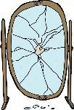**Glass Shatter Pattern Lab**

You can determine the order of impacts on glass by analyzing the radial fractures caused by the impact. Radial fractures terminate when they encounter a previous radial fracture. In this lab, you will create fracture patterns and analyze the order of impact.

**Supplies**

Hammer Nail Glass Slide Packing Tape Safety Glasses **must be worn at all times**

**Procedure**

1. Go over Glass ppt first.
2. Obtain a blank glass slide.
3. Using the clear packing tape, completely tape both sides of the slide
4. Put the slide in a cardboard box lid.
5. Place the nail, sharpened side touching the glass, on the glass and carefully strike the nail with the hammer. Do not hit the nail so hard as to drive it into the table.
6. Move the nail away from your impact region and repeat step 4 until you have three impacts with fracture patterns on your glass.
7. Replace the tape on your glass as needed so you are not exposed to sharp objects.
8. Draw the fracture patterns that you see on your piece of glass in the box below.
9. Label the radial and concentric fractures on your drawing.
10. Label the order in which the impacts to the glass occurred. Explain why you chose this order.

Repeat steps 7 -9 with another person’s glass slide.

What was the order of impact on the other person’s slide?

|  |  |
| --- | --- |
| Ballistics is the study of what happens to moving projectiles in the barrel and in flight; their trajectory, force, impact, and penetration. The trajectory, or the path a bullet travels from muzzle to impact, of a projectile can be determined if two reference points for the projectile can be found. | |
| Use the following link to access the PHET projectiles in motion lab:  <https://phet.colorado.edu/en/simulation/projectile-motion> Click the play button (no need to download anything). | |
| **Part 1** | |
| Click on Lab. Without changing any settings, select 3 different objects in the pull-down menu and fire ***without*** air resistance. Which objects did you select AND what do you notice about the path of the objects you selected? |  |
| Now select the air resistance button and fire the same three objects. What did you notice about the flight paths with resistance? |  |
| What does air resistance do to a projectile? Why? |  |
|  | |
| Move the target to a distance 20 meters from the cannon. With air resistance off and using the golf ball try each of the following shots.  Play around a little bit with different angles and speeds. Try another object. | |  |  |  |  |  |  | | --- | --- | --- | --- | --- | --- | | Angle (degrees) | 65° | 45° | 25° | 89° | 55° | | Initial Speed (m/sec) | 16 m/sec | 14 m/sec | 16 m/sec | 30 m/sec | 14 m/sec | | Hit or Miss |  |  |  |  |  | |
| What did you notice about angles 45◦ and 55◦? What about 65° and 25°? |  |
|  | |
| Explain how an understanding of projectiles in motion help investigators determine the location of a sniper in a case such as the JFK assassination? |  |

**Part 2**

Solve the following problems and SHOW ALL WORK to receive credit.

**Scenario 1:**

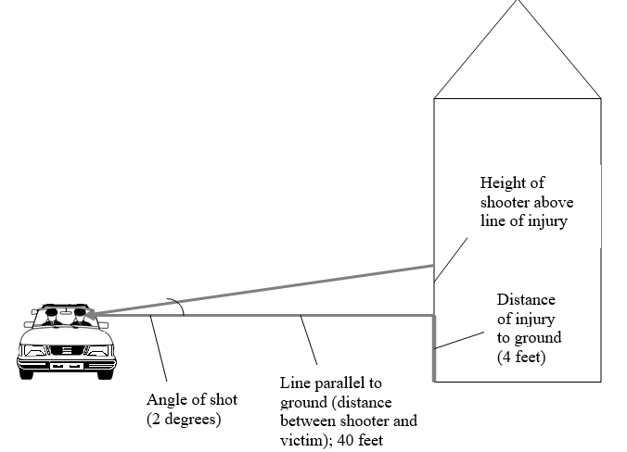A victim was shot from a bullet that came through his front car window as shown in the figure below. Witnesses saw a muzzle flash from a nearby building but were unsure from which floor the flash originated. The path or trajectory can be determined by using Point 1 (P1), the broken driver’s side window and Point 2 (P2), the point where the bullet entered the victim’s head. These points provide two reference points used to determine the angle of the shooter’s position above the driver’s location.

1. According to the sketch, the angle of trajectory is 2 degrees.
2. The distance to the building in question is 40 feet.
3. Calculate the height of the shooter using **tan (angle) = height / distance**.

(Remember the total height of the shooter is equal to your calculated

height **plus** the height from the injury to the ground.)

**Scenario 2:**

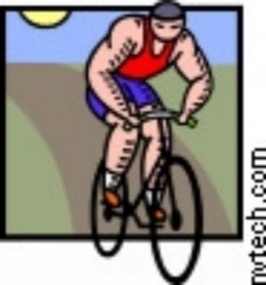Witnesses saw a victim fall while riding his bike. He had been struck in the head by a bullet. When the crime scene investigators arrived, they calculated the angle of elevation of the shooter to be about 6.5 degrees. The distance to the building from which the shot was fired was 152 feet and the height of the entry wound on the victim while on his bike measured 6 feet above the ground. Solve for the height of the shooter (above the ground, not above the victim’s injury).

**Scenario 3:**

A man is shot from a hotel window while sitting on a park bench. Use the following information to determine from which window the shot came. The trajectory angle is 25 degrees. The distance to the hotel is 100 feet and the person’s injury was five feet off the ground.



1. Label the diagram as shown in scenario 1 with all required information.
2. Calculate the distance above the ground where the shot was fired.
3. Which floor do you think the shooter was most likely standing in when he/she shot? Assume the average distance between floors in a hotel is 9 ½ feet.

Solve the following:

1. Angle of entry = 15° and height of shooter is 188 feet. What is the distance to the building ~__________ ft away
2. Angle of entry = 27° and height of shooter is 120 feet. What is the distance to the building ~__________ ft away
3. Angle of entry = 35° and the distance to the building is 85 feet Height of shooter ~_________ feet above horizon
4. List **3 possible problems** that might interfere with the accuracy of your results or an investigator’s results when determining were a shooter was located.

**Ballistics Hands-On Lab**

1. Caliber - Get a container with bullets and a caliper from up front. Measure the diameter of the bullets in both millimeters and inches and determine the caliber of each. The answers are in the container. How did you do? Explain.
2. Look at the bullets in the jar and see which ones came from the same gun.

What did you observe?

Look at the cartridges in another jar and see which came from the same gun.

What did you observe?

1. Get the container with fingerprinting supplies. Make a fingerprint on a cartridge and see if you can lift it. Tape it on here:
2. Get the container with miscellaneous items related to bullets. Look through them. What is one thing new you have learned from looking at them?

**Tool Marks Hands-On Lab**

Use various tools to make marks in Styrofoam. Imagine you are working a crime scene where a door was pried open. Would it be possible to determine the tool used? Explain.